Precision-Engineered Hapkit for Enhanced Haptic Feedback

Final Year Project Report
Submitted to the Department of Mechanical Engineering
In the partial fulfilment of the
Requirements for the degree of
Bachelor of Technology (B.Tech)
Isha Zargar
Maria
Supervised by:
Prof. Babar Ahmad


Department of Mechanical Engineering
National Institute of Technology
Srinagar—190006 India

July 2025
Declaration

We certify that:
- The work contained in this report is original and has been done by us under the guidance of our supervisor.

- The work has not been submitted to any other institute for any degree or diploma.

- We have followed the guidelines provided by the institute in preparing the report.

- We have conformed to the norms and guidelines given in the Ethical Code of Conduct of the Institute.

- Whenever we have used materials (data, theoretical analysis, figures, and text) from other sources,

- We have given due credit to them by citing them in the text of the report and giving their details in the references.

Further, we have taken permission from the copyright owners of the sources whenever necessary.

Isha Zargar (2021BMEC039)

Maria (2021BMEC037)

Certificate

This is to certify that the project work contained in the project report titled “Precision Engineered Hapkit for Haptic Feedback” submitted by “Isha Zargar and Maria” to the Department of Mechanical Engineering, National Institute of Technology Srinagar, J&K, India, is a record of bonafide project work carried out by them under my supervision and guidance and is worthy of consideration for the award of the degree of Bachelor of Technology in Mechanical Engineering of the Institute.

Supervisor
Professor Babar Ahmad
Co-Supervisor
Dr Suhail G. Khosa

Head of Department
Dr MF Wani

Date:

Abstract

Haptics, the study and application of tactile feedback technology, plays a vital role in enhancing human interaction with machines, particularly in fields that demand precision and intuitive control. With applications spanning medical training, virtual reality, and remote manipulation, haptic devices serve as essential tools for simulating real-world physical interactions within digital environments.
This report presents the development and implementation of a haptic interface using a Hapkit — a low-cost, open-source, one-degree-of-freedom haptic device designed by Stanford University. The objective of this project was to assemble, calibrate, and program the Hapkit to demonstrate force feedback in real time, allowing users to interact with a virtual environment through physical motion. The design includes custom 3D-printed components, a DC motor, an optical sensor for position tracking, and an Arduino-based control system to regulate force rendering based on user input.
The project emphasizes accessibility and modularity, allowing further experimentation in human-computer interaction, motor learning, and virtual training scenarios. By successfully integrating mechanical design, sensor feedback, and control programming, this work demonstrates how haptic technology can be both educational and impactful, paving the way for deeper exploration in the rapidly growing field of tactile feedback systems.

Acknowledgments

First and foremost, we express our deepest gratitude to the Almighty for granting us the strength, determination, and perseverance to successfully complete our final year project. We are profoundly thankful to our project supervisor, Prof. Babar Ahmad, Department of Mechanical Engineering, NIT Srinagar, for his invaluable guidance, constant encouragement, and unwavering support throughout the course of this project. His deep insight and belief in our capabilities were instrumental in navigating challenging phases of our work.
We also extend our sincere thanks to Prof. M.F.Wani, Head of the Department of Mechanical Engineering, NIT Srinagar, for providing us with essential departmental resources and a conducive environment to carry out our research.
A special note of appreciation goes to Dr. Suhail G Khosa at the Haptics and Mechatronics Devices (HAMD) Lab, whose assistance and expertise significantly contributed to the successful execution of this multidisciplinary project.

Isha Zargar (2021BMEC039)
Maria (2021BMEC037)

Contents

Abstract I
Acknowledgments II
List of Figures IV
1 Introduction 1
1.1 Overview of Haptics: 1
1.2 Significance of Haptic Technology 1
1.3 Major Research Domains in Haptic Technology 5
1.3.1 Human Haptics 6
1.3.2 Machine Haptics 8
1.3.3 Computer Haptics 9
1.4 Haptic Devices: An Overview 11
1.5 Motivation 15
1.6 Hapkit 16
2 Literature Review 17
3 Design and Fabrication of a Hap Kit 20
3.1 Objective: 20
3.2 Hardware 20
3.2.1 Brushed DC Motor: 21
3.2.2 FSR Sensor: 22
3.2.3 Neoprene drive 23
3.2.4 Arduino Uno: 24
3.2.5 3D Printed parts 25
3.2.6 Rotary encoder 26
3.3 Working of The Hapkit 26
3.3.1 Code 27
4 Mechanics of the Device 31
4.1 Kinematic Configuration 31
4.2 Force Transmission 32
4.3 Structural Mechanics 33
4.3.1 Sensor Integration and Mechanical Interface 33
5 Conclusion 34
6 Future Works 35
7. References 36

List of Figures

Figure 1 Exoskeleton Gloves 2
Figure 2 Advanced Prosthetic Limbs 2
Figure 3 Environment–user virtual interactions: (a) Touching: Generating sensations such as pain, pressure, temperature, etc. (b) Smelling: Producing sensitivity to odours, aromas, flavours, etc. (c) Listening: Transmitting sounds, rhythms, tunes, etc. (d) Feelings: Eliciting emotions and comfort atmosphere. (e) Vision: Generating accessible virtual environments. 3
Figure 4 Razer Freyja Gaming Pad 4
Figure 5 Sony’s PlayStation 5 Dual Sense controller 4
Figure 6 The Tesla Suit 5
Figure 7 The Interconnected Domains of Haptics Research 6
Figure 8 Neural pathway of haptic perception: from skin contact to brain interpretation. 7
Figure 9 Prosthetic Technology/ Arm Dynamics 8
Figure 10 Schematic representation of machine haptics: Illustrates the interactive feedback loop between user input and electromechanical haptic output, central to realistic touch-based experiences in virtual or remote environments. 9
Figure 11 A user equipped with VR and haptic devices (left) controls a virtual character (right), enabling immersive interaction and touch feedback in a virtual environment 10
Figure 12 Components of Haptic device 12
Figure 13 Phantom Omni Force Feedback Device 13
Figure 14 Hand Touching Smartphone 14
Figure 15 The da Vinci Surgical Robot 15
Figure 16 Final Prototype 17
Figure 17 The RF-370CA motor 21
Figure 18 FSR402 (Force Sensitive Resistor) 22
Figure 19 Arduino UNO R4 Minima (ABX00080) 24
Figure 20 Rotary Encoder 26
Figure 21 Impedance Control Loop of a Hapkit 27

Introduction

Overview of Haptics:

"Haptics" is derived from the Greek verb "haptesthai," which pertains to the sense of touch. Within the realms of psychology and neuroscience, haptics encompasses the investigation of human perception and manipulation of objects via tactile sensory modalities. This field incorporates kinesthetic sensors, which are responsible for detecting force and position, as well as cutaneous sensors, which are tasked with recognizing tactile sensations. The sense of touch can be categorized as either cutaneous or kinesthetic, contingent upon the type of neural inputs received by the brain. The cutaneous (tactile) system employs receptors located within the skin, whereas the kinesthetic system utilizes receptors found in muscles, tendons, and joints.
Haptics represents a significant area of research in robotics and virtual reality, focusing on the examination of tactile interactions—both physical and virtual—among humans, robots, and real or simulated environments. The integration of haptic technology with robotics is largely attributed to its reliance on advanced mechatronic systems. Haptic interfaces harness mechatronic devices and computerized controls to replicate or enhance the tactile sensations associated with perceiving or manipulating objects in the physical domain. This capability to reproduce authentic physical experiences or to generate entirely novel sensations greatly augments human-computer interaction (HCI) and the modalities of our interactions with technology.

Significance of Haptic Technology

Haptic technology refers to the field of science that bridges the gap between mechanical systems and the human sense of touch. It enables users to receive tactile sensations—such as pressure, vibration, or resistance—through an interface that replicates real-world interactions within virtual environments. This process, known as haptic feedback, allows for a two-way flow of information between human users and digital systems, where virtual responses are physically felt by the user based on the simulated environment.
The primary objective of haptics is to enhance realism in simulations and improve user immersion by mimicking the sensations encountered during real-life interactions. Through the integration of actuators and sensors, haptic systems replicate the feel of manipulating physical objects—even when they only exist in digital form. Haptic technology has grown beyond its initial applications in gaming and consumer electronics to become a cornerstone in fields such as medical training, robotics, virtual reality (VR), rehabilitation, and education. By enabling physical interaction with digital systems, haptics facilitates intuitive control, enhanced realism, and muscle memory development—attributes that are critical in both professional and learning environments.
For instance, haptic feedback systems are increasingly employed in rehabilitative devices aimed at aiding stroke survivors or patients with motor impairments; for example, exoskeleton gloves fitted with force feedback mechanisms allow users to regain lost hand movement by mimicking natural motion and providing resistance during therapy. This method encourages muscle reactivation and neuroplasticity.

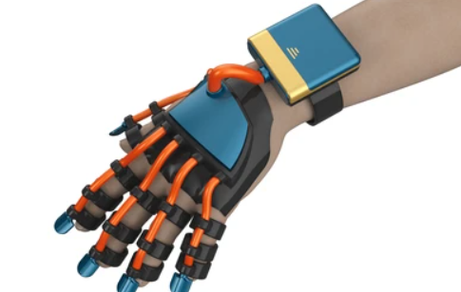
Figure 1: Exoskeleton Gloves

Moreover, advanced prosthetic limbs equipped with haptic sensors allow amputees to perceive pressure, texture, or even temperature. Sensors on the artificial limb send signals back to the residual limb, often through vibration or electrical stimulation, offering a more intuitive control experience.

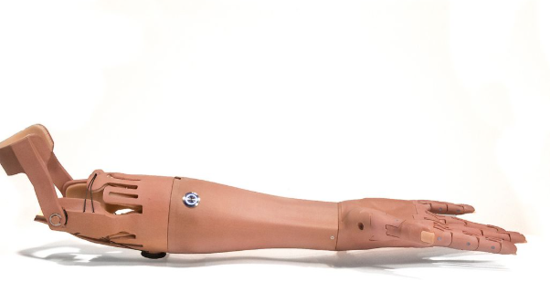
Figure 2 Advanced Prosthetic Limbs

Rehabilitation is one of the most promising frontiers for haptic technology. Patients recovering from neurological disorders like stroke or cerebral palsy often require repetitive motor training with physical guidance. As illustrated in, digital virtual environments are full of tools that enhance user immersion and decision-making processes, including haptic devices.

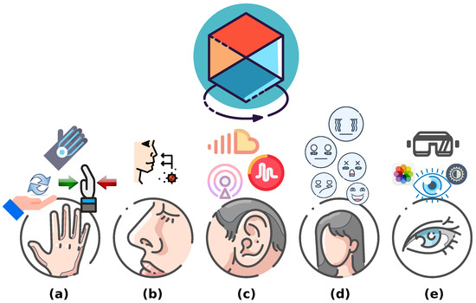
Figure 3. Environment–user virtual interactions: (a) Touching: Generating sensations such as pain, pressure, temperature, etc. (b) Smelling: Producing sensitivity to odors, aromas, flavors, etc. (c) Listening: Transmitting sounds, rhythms, tunes, etc. (d) Feelings: Eliciting emotions and a comfortable atmosphere. (e) Vision: Generating accessible virtual environments.

Similarly, the gaming industry has seen a dramatic transformation with the integration of haptic technologies. Haptic devices enrich the gaming experience by simulating realistic touch sensations corresponding to in-game events. These sensations can include vibrations, resistance, textures, and force feedback, making the virtual environment feel physically tangible. For instance, Razer Freyja (Figure 4) is a computer chair pad that allows players to experience physical vibrations while gaming. The device provides realistic tactile sensations that match the events in the game, from the vibration of a race car engine to the tense silence during a covert mission.

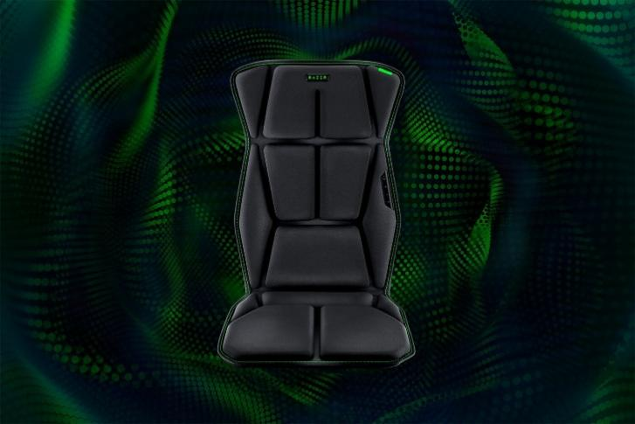
Figure 4 Razer Freyja Gaming Pad
In traditional console and mobile games, basic vibration motors in controllers or smartphones provide feedback when, for example, a player crashes a car, takes damage, or fires a weapon. However, with the advent of advanced haptic interfaces like haptic vests, gloves, and exoskeleton controllers, players can now feel the direction and intensity of impacts, the recoil of weapons, or the resistance of drawing a bowstring. This significantly enhances immersion and engagement. One of the examples is Sony’s PlayStation 5 DualSense controller (Figure 5). The device not only relies on voice coil actuators, but the adaptive triggers are also powered by an additional DC motor. This transmits additional active haptic feedback, like increased resistance or actively pushing against the finger, using a gear mechanism.

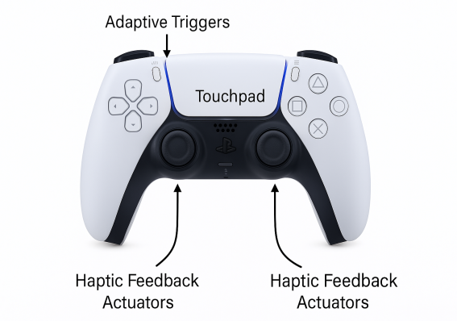
Figure 5 Sony’s PlayStation 5 DualSense controller

In VR and AR systems, haptics plays a central role in bridging the gap between the digital and physical worlds. While visual and auditory inputs allow users to perceive virtual environments, haptic feedback makes it possible to interact with them meaningfully. This interaction is essential for a complete sense of “presence”—the psychological feeling of truly being inside the virtual space. Furthermore, full-body haptic suits (like the Tesla suit) are being developed to deliver feedback across multiple body zones, enabling users to experience environmental conditions (e.g., heat, cold, wind) or physical impacts across their entire body.

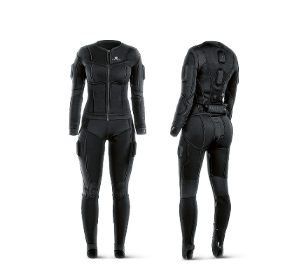
Figure 6: The Tesla Suit

Major Research Domains in Haptic Technology

Haptics is a multidisciplinary field with diverse research areas that explore how humans perceive and interact with their environment through the sense of touch. Broadly, research in haptics can be categorized into three interconnected domains:
- Human Haptics
- Machine Haptics
- Computer Haptics
Figure 7 illustrates the interconnected domains of haptics research.
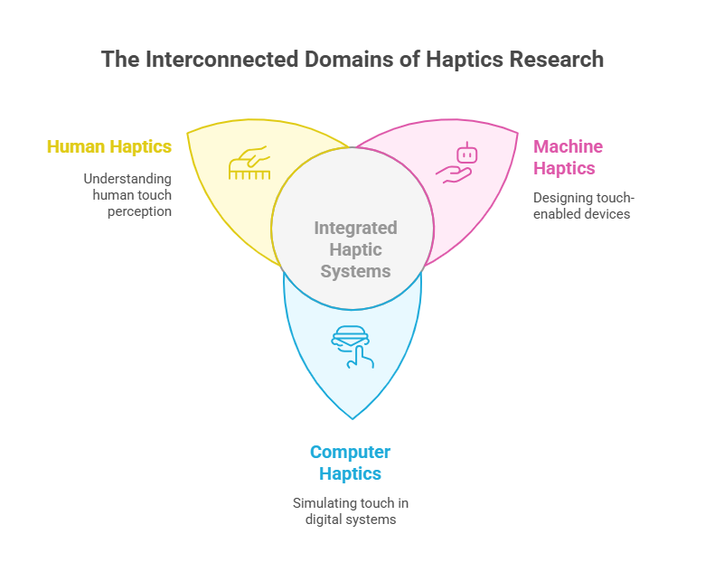
Figure 7: The Interconnected Domains of Haptics Research

1.3.1 Human Haptics
Human haptics is a rich and interdisciplinary research area that focuses on how humans perceive, interpret, and respond to physical interactions through the sense of touch. It encompasses both tactile sensations, which arise from contact with the surface of the skin, and kinaesthetic sensations, which are associated with movement, force, and position of the muscles and joints. Figure 8 illustrates the biological mechanism of touch (haptic perception). When the skin encounters an object (stimulus), sensory receptors located in the dermis detect the mechanical interaction. These receptors send signals through nerves, which carry the information to the brain via neural pathways. The brain then processes these signals, resulting in the perception of touch, such as texture, pressure, or temperature. The inset shows a magnified view of the skin layers, highlighting the role of sensory receptors and nerves in initiating the haptic feedback loop.

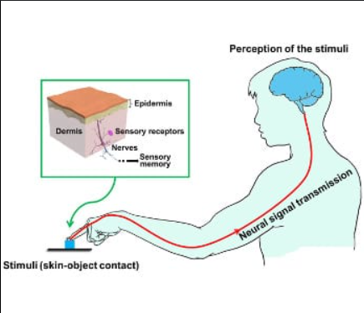
Figure 8: Neural pathway of haptic perception: from skin contact to brain interpretation.

The study of human haptics draws from various scientific domains, including neurophysiology, cognitive psychology, biomechanics, and sensory neuroscience, to understand how the human body receives and processes haptic information. This understanding is critical not only for building accurate models of human perception but also for designing responsive systems in fields like robotics, virtual reality, prosthetics, and rehabilitation.
At the core of human haptic perception is the human sensorimotor loop, which integrates sensory input and motor output to create a cohesive interaction with the environment. When a person touches or manipulates an object, specialized sensory receptors in the skin and deeper tissues are activated. These mechanoreceptors include Merkel cells, which respond to sustained pressure and texture; Meissner’s corpuscles, which detect light touch and dynamic changes in skin deformation; Ruffini endings, which are sensitive to skin stretch and help with the perception of hand shape and motion; and Pacinian corpuscles, which respond to high-frequency vibrations. Each type of receptor plays a unique role in gathering detailed and layered information about the object being touched, such as its size, shape, texture, weight, and movement.
Once these receptors are activated, they transmit electrical signals via peripheral nerves to the central nervous system. The signals pass through the spinal cord and are processed in various areas of the brain, particularly the somatosensory cortex, which is responsible for interpreting touch, pressure, temperature, and proprioception (the sense of body position and movement). This complex and highly organized pathway ensures that haptic information is rapidly analyzed, integrated with other sensory data (such as vision), and converted into an appropriate motor response. The motor system then generates corresponding muscle commands to carry out actions like grasping, lifting, adjusting grip, or withdrawing the hand in case of discomfort or danger. This bidirectional flow of sensory and motor information forms a feedback loop that enables humans to interact with their surroundings in a precise, adaptive, and intuitive manner.
The insights gained from studying human haptics have significant real-world applications. One prominent area is in the development of advanced prosthetic limbs that provide tactile or force feedback, allowing users to regain a sense of touch and better control their artificial limbs (Figure 9)

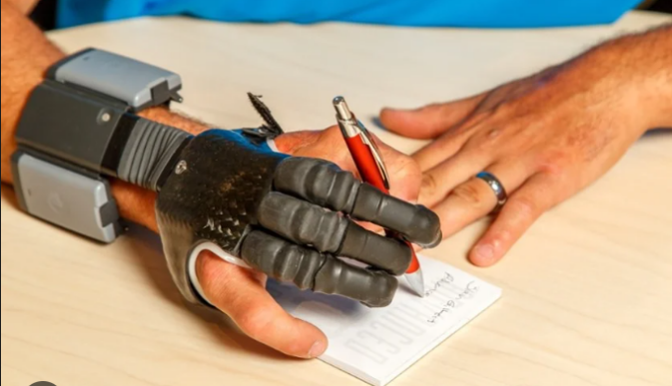
Figure 9 Prosthetic Technology/Arm Dynamics

Human haptics also plays a critical role in neurological rehabilitation, where haptic stimuli are used to retrain motor pathways in patients recovering from stroke, injury, or neurodegenerative conditions. In the realm of cognitive psychology, researchers use haptic tasks to study learning, memory, spatial reasoning, and perceptual development, particularly in children or individuals with visual impairments. Moreover, industries focused on ergonomic design—such as automotive, consumer electronics, and industrial tools—use knowledge of human haptics to create products that are more comfortable, intuitive, and responsive to human touch.
In conclusion, human haptics is the biological and psychological foundation upon which all haptic technology is built. By studying the intricacies of how humans sense and interpret touch, researchers and engineers can develop more natural, effective, and inclusive systems for communication and control, spanning everything from medical devices to immersive virtual environments.

1.3.2 Machine Haptics
Machine haptics is a foundational domain within the field of haptic technology that focuses on the design, development, and deployment of electromechanical systems capable of reproducing or augmenting the sense of touch. These systems, commonly known as haptic devices or haptic interfaces, form the physical layer that connects human users to digital or remote environments. Their core function is twofold: they detect and measure human input—such as hand position, motion, or applied force—and respond by delivering appropriate tactile or kinaesthetic feedback. In doing so, machine haptics creates an interactive feedback loop that simulates the mechanical and sensory properties of real-world interactions. This not only enhances realism in virtual experiences but also enables humans to interact safely and effectively with objects or environments that are distant, dangerous, or otherwise inaccessible.

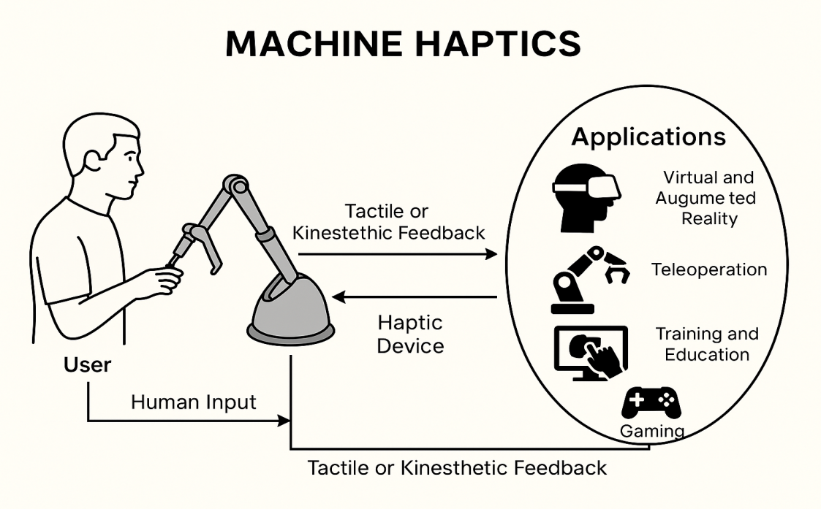
Figure 10:
Schematic representation of machine haptics: Illustrates the interactive feedback loop between user input and electromechanical haptic output, central to realistic touch-based experiences in virtual or remote environments.

Machine haptics finds application in a wide variety of fields. In virtual reality (VR) and augmented reality (AR), haptic devices add a physical layer to visual immersion, enabling users to touch and manipulate digital content as if it were real. In teleoperation, such as robotic surgery or remote exploration, haptic interfaces allow operators to control distant robotic systems while receiving real-time tactile feedback. improving precision and safety. In training and education, haptic systems provide hands-on practice in environments that are too expensive, risky, or rare to replicate physically. Additionally, industries such as gaming, automotive design, rehabilitation, and assistive technology are increasingly adopting machine haptics to create more intuitive and engaging user experiences.
Thus, machine haptics represents the mechanical and interactive side of haptic technology. By enabling physical feedback that responds to user input, it serves as a crucial link between the human body and digital or remote environments. Whether enhancing realism in simulations or enabling complex remote operations, machine haptics continues to expand the boundaries of human-machine interaction.

1.3.3 Computer Haptics

Computer haptics is a crucial research area within the field of haptic technology that deals with the creation of software and algorithms responsible for simulating touch-based interaction in virtual environments. Unlike human haptics, which focuses on the sensory-motor pathways of the human body, and machine haptics, which involves the design of physical devices, computer haptics is primarily concerned with the virtual experience of touch. It determines how digital objects should behave when interacted with, how collisions should be detected, and how the resulting forces should be computed and sent back to the user via a haptic device. The core objective of computer haptics is to make virtual interactions feel real by offering precise and stable force feedback in real time. This process of simulating the sense of touch digitally is referred to as haptic rendering, which is the touch-based counterpart of graphical rendering.
Haptic rendering consists of several integral components. The first is avatar representation, which refers to the virtual model of the haptic device or the user’s tool within the simulated environment. This avatar moves in accordance with the user’s physical motions and is the medium through which the user interacts with virtual objects (Figure 12).

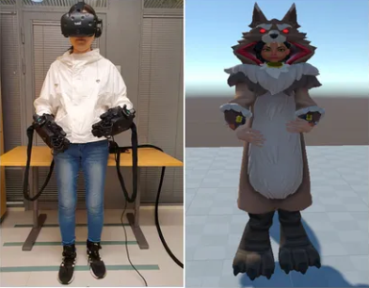
Figure 11: A user equipped with VR and haptic devices (left) controls a virtual character (right), enabling immersive interaction and touch feedback in a virtual environment
.
Different types of avatars exist depending on the application and computational capability of the system. A point-based avatar, which has three degrees of freedom (3-DOF), is the simplest and is commonly used due to its computational efficiency. More advanced applications may use object-based avatars with six degrees of freedom (6-DOF), enabling full orientation and manipulation of 3D virtual objects. Additionally, multipoint avatars allow the simulation of more complex grips, such as those involving multiple fingers, while volumetric avatars are employed in high-precision tasks such as surgical simulations to represent instruments used for cutting, drilling, or probing inside the human body.
Another essential part of computer haptics is collision detection. This module determines when and where the avatar contacts a virtual object. The accuracy and speed of this detection process are vital, as any lag can disrupt the user's immersive experience and make the force feedback feel unnatural. In complex virtual environments, collision detection becomes computationally intensive due to the presence of numerous objects and surfaces. To improve performance, techniques like hierarchical bounding volumes are used. These reduce the complexity of calculations by focusing on detecting collisions in the immediate proximity of the avatar instead of checking every object in the environment. This significantly reduces the workload and speeds up the process without sacrificing accuracy.
Once a collision is detected, the force response algorithm is triggered. This algorithm is responsible for calculating the type, direction, and intensity of force that should be rendered to the user through the haptic device. The algorithm takes into consideration various factors such as the penetration depth—how deeply the avatar has entered the virtual object—and the surface properties of the object, including stiffness, texture, friction, and roughness. The goal is to generate realistic force feedback that accurately mimics how the object would feel if touched in the real world. For example, interacting with a rubbery surface should feel soft and elastic, while touching a metallic object should give a harder, more resistant sensation.
Lastly, a key feature of computer haptics is its bidirectional interaction capability. Haptic systems don’t just send feedback to the user; they also continuously receive input from the user through the haptic device. This forms a closed loop where energy and information flow in both directions—user to computer and computer to user. To ensure a smooth and stable experience, this loop must operate at extremely high update rates, typically over 1 kHz (1000 updates per second). Any lag in this loop can result in unstable or jerky feedback, which can degrade the overall interaction experience and even pose safety issues in sensitive applications like robotic surgery. Therefore, advanced haptic control algorithms are implemented to ensure system stability, especially in devices that are low-power or have limited mechanical strength.
In conclusion, computer haptics plays a fundamental role in bridging the gap between the virtual and physical worlds. It provides the software backbone that enables users to physically feel computer-generated environments. Whether in medical simulation, virtual prototyping, gaming, or remote robotic control, computer haptics ensures that the forces and tactile sensations felt by the user are both realistic and responsive, enhancing immersion, precision, and interactivity in virtual systems.

Haptic Devices: An Overview
Haptic devices are sophisticated electromechanical systems that form the essential hardware component of any haptic interaction. These devices are specifically engineered to establish a physical connection between a user and a virtual or remote environment by simulating the sense of touch. They function as a medium that enables the user to both input physical actions (such as movement or applied force) and receive corresponding tactile or kinaesthetic feedback. By doing so, they effectively close the loop between human physical actions and computer-generated responses, allowing users to feel what they see in a digital domain.
At a functional level, a haptic device is composed of several core components that work together to facilitate interactive touch-based communication. Sensors within the device track parameters such as position, velocity, orientation, and applied force by the user. These sensors may include potentiometers, encoders, force-sensitive resistors, and inertial measurement units, all of which convert mechanical inputs into digital signals. Actuators are then used to produce feedback by generating mechanical stimuli that can be felt by the user. These stimuli can be in the form of vibrations, forces, or temperature changes and are commonly generated using motors, piezoelectric actuators, or vibrotactile elements. The entire system is coordinated by a real-time control unit, often powered by microcontrollers or embedded processors, which processes the sensor data, computes the appropriate feedback, and ensures the system's responsiveness and stability. The physical structure of the device—which may include robotic arms, linkages, or wearable gloves—serves to transmit forces and movements between the device and the user. Figure 11 illustrates the components of a haptic device precisely.
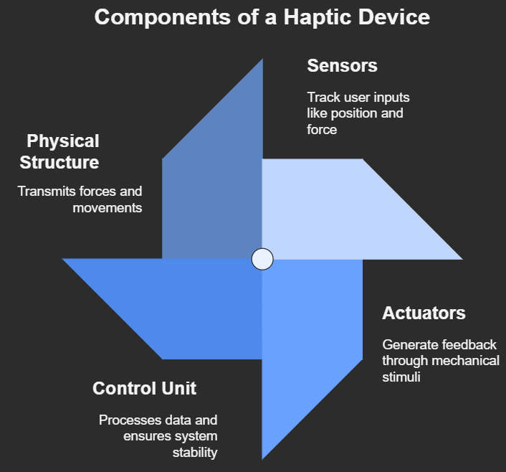
Figure 12: Components of Haptic device

Haptic devices are generally categorized based on the type of feedback they deliver.
- Force feedback devices simulate mechanical properties such as resistance, weight, inertia, or compliance. These devices usually operate like robotic arms or actuated linkages that push or pull against the user’s hand or fingers in response to virtual interactions. For example, when a user tries to push a virtual object, a force feedback device resists the motion to mimic the object’s stiffness or weight. This allows the user to "feel" the object as if it were physically present. Force feedback is crucial in applications where physical manipulation and precise control are required—such as surgical simulators, robotic arms for space or hazardous environments, or immersive virtual prototyping. One such examples is the Phantom omni force feedback device (Figure 10)

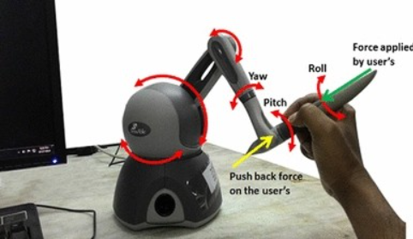
Figure 13 :Phantom Omni Force Feedback Device

Figure 10 shows the Phantom Omni Force Feedback Device with a stylus held by the user. As the user applies force and moves the stylus, the device senses motion in yaw, pitch, and roll directions. In response, it applies a push-back force using motors, letting the user feel virtual surfaces or resistance. This simulates real touch in virtual environments.

- Tactile devices are focused on stimulating the skin’s surface with detailed sensations like vibration, pressure, temperature, or texture. These systems may use arrays of actuators, vibratory motors, pin arrays, or even thermal elements to reproduce the subtle cues that characterize how different materials and surfaces feel. For instance, a tactile display on a touchscreen can simulate the feeling of sandpaper or silk by modulating friction or micro-vibrations under the user’s finger. Similarly, a user feeling vibrations while touching a phone is also experiencing tactile feedback (Figure 11)

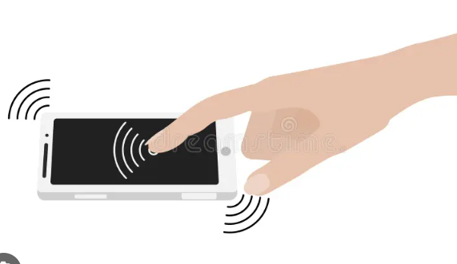
Figure 14: Hand Touching Smartphone

Tactile feedback is particularly valuable in consumer electronics, wearable devices, Braille readers, and any interface that requires the transmission of non-verbal, sensory-rich information through touch.

A critical performance parameter of haptic devices is their degrees of freedom (DOFs)—that is, the number of independent directions in which the device can move or exert force. A simple 1-DOF device might only allow back-and-forth movement along a single axis, while more advanced devices may support 3-DOF translation (X, Y, Z) and 3-DOF rotation (pitch, yaw, roll), totalling 6-DOF. The greater the number of DOFs, the more nuanced and realistic the haptic interaction becomes. Some high-end haptic interfaces used in research or industrial simulation can even support additional DOFs through modular or multi-fingered designs.
The utility of haptic devices spans across a wide range of domains. In the medical field, they are used for surgical simulation, dental training, and physical rehabilitation, allowing trainees and patients to interact with virtual tissues and instruments in a realistic manner. For example, the da Vinci Surgical Robot uses haptics to enhance precision and control during minimally invasive surgeries. While early versions lacked true haptic feedback, recent advancements incorporate force-sensing and tactile feedback systems that allow surgeons to feel resistance or tissue interaction through robotic instruments. This improves surgical accuracy, reduces tissue damage, and enhances the surgeon's sense of touch, making robotic-assisted procedures more intuitive and safer.

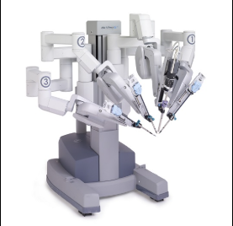
Figure 15: The da Vinci Surgical Robot

In the realm of teleoperation, haptic devices are employed to control robotic arms in remote or hazardous environments, such as deep-sea exploration, bomb disposal, or space missions. The gaming and virtual reality industries also benefit immensely from haptic technology, as it significantly enhances immersion by allowing players to feel in-game actions such as gun recoil, collisions, or object textures. Furthermore, haptic devices serve as invaluable tools in research and education, especially for teaching principles of dynamics, control systems, and perception. Designers and engineers Also, use Use haptic systems in digital prototyping, enabling them to “feel” and assess virtual products before committing to physical manufacturing.

Motivation
Haptic technology is steadily transforming how humans interact with machines by introducing tactile and force feedback into digital experiences. Despite its rapid evolution, haptics remains relatively underutilized in affordable educational tools and accessible rehabilitation devices. The current market is saturated with high-cost, high-fidelity haptic devices such as the Geomagic Touch (formerly Phantom Omni), which, while excellent for research and industry-grade simulation, are far from practical for widespread use in schools, developing regions, or home-based therapy setups. This disparity highlights a growing need for cost-effective, compact, and modifiable haptic interfaces that can be used both in resource-constrained environments and for specialized applications like motor rehabilitation and STEM education. Our project, inspired by the Hapkit initiative from Stanford University, seeks to fill this gap by developing a low-cost, 1-DOF rotary haptic device (Hapkit) that is both mechanically simple and electronically flexible. Unlike complex multi-DOF robotic arms, our Hapkit uses a rotary DC motor coupled with a flexure-based paddle, allowing for continuous smooth motion and force feedback within a single rotational axis. The system employs a custom-built drive mechanism based on a neoprene belt and replaces the traditional capstan or gear trains with harmonic drive-like arrangements to ensure near-zero backlash—critical for realistic haptic rendering. A precision potentiometer is used in place of a Hall-effect sensor to monitor angular displacement and enable closed-loop control.
The motivation behind developing this device lies in its versatility and inclusiveness. First, it has vast potential as a learning tool in engineering and science education. By integrating it with interactive software, students can gain hands-on experience with physics concepts like spring-damper systems, force fields, and kinematics. Instead of only observing simulations on a screen, they can physically feel forces and gain a kinaesthetic understanding — a powerful pedagogical advantage.
Second, the Hapkit could serve as an assistive tool for motor learning and rehabilitation. Individuals recovering from strokes or those with congenital motor disabilities often require repeated, guided hand motions to rebuild muscle memory and coordination. Our device allows for customizable, programmable resistance and guidance forces, simulating therapeutic environments tailored to individual progress. The low cost and portability also make it viable for home-based rehabilitation, bypassing the need for expensive clinics or long commutes.
Third, the simplicity of the device—in terms of hardware and software—opens it to open-source development and community-driven innovation. Students, hobbyists, and researchers can modify the firmware, experiment with different control algorithms, or adapt the mechanical design to include more degrees of freedom. This not only fosters an inclusive ecosystem of innovation but also ensures that the technology evolves organically with real user feedback.
Furthermore, the use of Arduino-compatible microcontrollers and readily available materials ensures that the device can be built and deployed even in educational institutions with limited infrastructure. The 3D-printed parts used for the structure allow for rapid prototyping and easy replication, while modularity makes it simple to replace or upgrade components such as the motor, belt, or sensors.
The motivation to build this haptic device also stems from the ongoing shift in how people interact with virtual and augmented realities. As industries and educational institutions adopt more immersive digital tools, the lack of tactile feedback remains a key limitation in ensuring full engagement. The Hapkit, though fundamentally simple, offers a gateway into this realm by delivering an affordable tactile experience that enhances user immersion and skill transfer.

Hapkit

The Hapkit is a one-degree-of-freedom (1-DOF) haptic device that utilizes a closed-loop belt drive system to provide high-resolution force feedback to the user. As shown in Figure 16, the mechanism consists of a semicircular rotating arm attached to a motor shaft through a neoprene timing belt, with motion sensed by a potentiometer mounted co-axially. This belt-and-pulley design replaces traditional rigid linkages, allowing smooth, low-backlash transmission of motion between the user's hand and the actuator. The arc-shaped link of the Hapkit restricts the motion to a planar rotational degree of freedom, which is ideal for demonstrating force-displacement relationships and simple haptic interactions. For our project, this device is used as a fundamental interface to sense user input motion and respond with controlled forces, enabling a variety of virtual environments to be simulated in one dimension. The feedback loop is closed using a real-time control algorithm implemented on an Arduino microcontroller, which reads the position data from the potentiometer, computes the appropriate feedback force, and drives the DC motor accordingly. The Hapkit’s compact design, simplicity of construction, and open-source support make it highly suitable for educational and experimental use in haptic applications. Unlike the pantograph, which permits 2-DOF planar movements, the Hapkit is more constrained but compensates with precision, lower inertia, and greater control over force rendering, which is critical for rendering virtual springs, walls, or damping fields with high fidelity. Its modular architecture also allows enhancements like force sensors or harmonic drives to be integrated for research applications requiring higher accuracy or zero backlash performance.

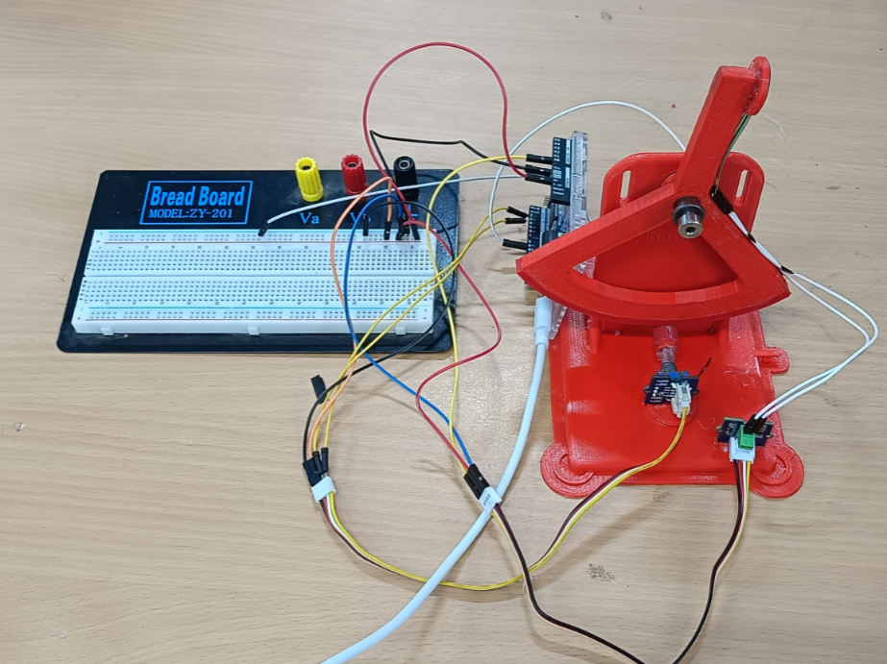
Figure 16: Final Prototype

Literature Review

Recent advances in haptic technology have significantly changed how humans interact with devices. Many of these discoveries have greatly influenced our project, providing both inspiration and practical insights.
Below are some key studies that have shaped our work:

- Stanford University (ME327 Class): Stanford University offers an extensive course on haptics, focusing on the design, control, and applications of haptic devices. This foundational knowledge is critical for understanding the broader landscape of haptic technology.

- Educational Haptics—Morimoto Lab: The Morimoto Lab at UC San Diego conducts research on educational haptics, including the development and application of the Hapkit. Their work focuses on creating low-cost, easy-to-assemble haptic devices to enhance learning in STEM fields.

- Stanford University x Seeed: Open-Source Haptic Device for Affordable Haptics Education for All :This article details a collaboration between Stanford University and Seeed Studio to develop an all-in-one controller board for the Hapkit, significantly reducing costs and simplifying the assembly process. The initiative aims to make haptic education more accessible globally.

- Melisa Orta Martinez, Cara M. Nunez, Ting Liao, and Tania K. Morimoto—Evolution an Analysis of Hapkit: An Open-Source Hapkit Device for Educational Applications: This research explores the development and optimization of Hapkit, a low-cost, open-source haptic device designed for educational use. By improving its mechanical design and system performance, the study highlights Hapkit’s potential for enhancing interactive learning in dynamics and control, as well as its broader applicability in accessible haptic education and training.

- Alexandra Miller, Naveed D. Riaziat, and Jeremy D. Brown - An Open-Source Ungrounded Hapkit for Educational Applications: The paper titled “An Open-Source Ungrounded Hapkit for Educational Applications” introduces a modified version of the original Hapkit haptic device, designed to provide ungrounded kinaesthetic feedback. Unlike traditional haptic devices that require a fixed base, this ungrounded variant can generate torque at the user's wrist without being anchored, enabling more versatile interactions in virtual environments.

- Christopher Richard, Allison M. Okamura, and Mark R. Cutkosky—Getting a Feel for Dynamics: Using Haptic Interface Kits for Teaching Dynamics and Controls: This paper discusses the use of low-cost, single-axis force-reflecting joysticks to teach students about electromechanical systems, dynamics, and controls, emphasizing the value of hands-on learning.

- Eloy Irigoyen, Mikel Larrea, Manuel Grana, A Narrative Review of Haptic Technologies and Their Value for Training, Rehabilitation, and the Education of Persons with Special Needs: This review examines the broad spectrum of haptic technologies, from force feedback to pseudo-haptics, and their applications in education, training, and rehabilitation, highlighting their growing importance in human–computer interaction.

- Robert Bloom, Zachary Huang, Kaitlyn Lavarias, Tania K. Morimoto - H 3 Kit: Hand-Held Haptic Kit for STEM Education: The conference paper presents the design and application of a novel, low-cost, open-source haptic device aimed at enhancing STEM education. Developed by researchers at UC San Diego, the H3Kit is a wearable, forearm-mounted device that provides kinaesthetic feedback through wrist flexion and extension movements. It enables users to interact physically with virtual environments, facilitating experiential learning of scientific and

- Muhammad Fouad, Tamer Mansour, and Tamer Nabil—Use of haptic devices in education: A review: This comprehensive review discusses how haptic technology transforms passive learning into active, hands-on experiences, particularly beneficial in STEM education. It covers various haptic devices used across educational fields and addresses challenges in widespread adoption.

- Melisa Orta Martinez—Design and analysis of open-source educational haptic devices: This doctoral dissertation presents an in-depth analysis of the design considerations and educational applications of open-source haptic devices, including the Hapkit. It provides valuable insights into the development process and pedagogical impact of such tools.

While many haptic devices exist in the commercial and research space, they are often overly complex and expensive for foundational educational purposes. Most are designed with three or more degrees of freedom, which makes them suitable for advanced applications but unnecessary for basic learning tasks like exploring force feedback, system dynamics, or control principles. This added complexity not only increases cost but also makes them harder to assemble, maintain, and integrate into classroom environments. In our review, we found that 1-DOF devices, which are sufficient for demonstrating core haptic concepts, are underrepresented in literature and rarely optimized for affordability and ease of use. With these factors in mind, our project focuses on building a 1-DOF, low-cost educational haptic device using motor actuation, designed to provide accurate and accessible hands-on learning in haptics for students and educators alike.

Design and Fabrication of a Hap Kit

Objective:

The objective of this project is to design and implement a low-cost, open-source haptic device using the Hapkit platform to provide kinaesthetic force feedback and resistance through virtual environmental interactions. The system will simulate features such as a virtual wall, enabling users to experience realistic physical boundaries and dynamic resistance. This interaction is achieved using an impedance-type control system, where the position of the user's input is continuously tracked to generate appropriate feedback forces. Such a setup aims to enhance user understanding of physical principles and control dynamics, making it particularly valuable for educational applications and virtual training environments.

Hardware

To achieve the objectives mentioned above, various transducers and components are utilized for determining position, computing force feedback, and providing output force to the user.
• Brushed DC Motor
• FRS Sensor
• Neoprene Drive
• Arduino Uno
Additionally, we have 3D- printed custom-designed structural parts that serve as the main body of our Hapkit.
The selection of each component is based on various parameters, which will be discussed in the following sections.

Brushed DC Motor:
For our application involving force feedback, we needed a motor to deliver sufficient torque to render virtual walls and forces accurately. Additionally, the motor required simple control using PWM (Pulse Width Modulation), which could be integrated with a high-resolution encoder to enhance position and velocity feedback precision.
A brushed DC motor is a flexible and economical choice for haptic applications in our Hapkit project, since customization and dynamic force feedback are our priorities. DC motors do not include built-in position feedback or control circuitry, requiring the use of external components such as encoders or potentiometers and motor drivers to implement closed-loop control. While this adds complexity, it also allows for greater design freedom and fine-tuning of haptic behaviour through custom control algorithms.

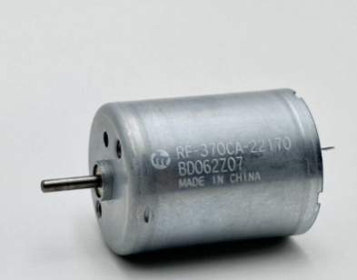
Figure 17: The RF-370CA motor

The RF-370CA is compact, lightweight, and operates effectively at low voltages (typically 3–12 V), making it well-suited for handheld educational devices. When integrated with a microcontroller and appropriate feedback mechanisms, this motor can simulate essential haptic effects such as spring forces, damping, or virtual walls by dynamically adjusting torque based on user input. Although it lacks the position-holding capabilities of a servo and introduces challenges like gear backlash and brush wear, the RF-370CA’s affordability, availability, and versatility make it a practical option for prototyping force-feedback systems where real-time responsiveness and adaptability are key. For our Hapkit, the RF-370CA serves as the actuator to create dynamic force sensations through motor-driven resistance and programmed interaction forces.

FSR Sensor:

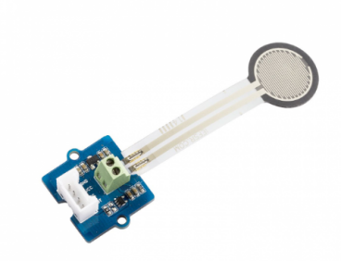
Figure 18: FSR402 (Force Sensitive Resistor)

The FSR402 (Force Sensitive Resistor) is a thin, flexible sensor that changes its electrical resistance based on the force applied to its surface. This makes it ideal for detecting human touch or applied pressure in interactive systems. It operates on a simple principle: as force increases, the resistance across the sensor decreases in a non-linear fashion. In its resting state (no pressure), the resistance is extremely high (>10 MΩ), but when pressed, it can drop to a few hundred ohms. The sensitive force range of the FSR402 typically spans from 0.2 N to 20 N, making it well-suited for detecting finger pressure or light mechanical contact.
Internally, the FSR402 consists of two film layers—one with conductive traces and another coated with a pressure-sensitive ink. When pressure is applied to the circular sensing area (approximately 12.7 mm in diameter), the conductive material makes better contact, reducing resistance. This change in resistance can be captured using a voltage divider circuit, which allows microcontrollers like Arduino to interpret the sensor’s output as an analog voltage signal.
In our Hapkit project, the FSR402 is strategically mounted on the handle or interaction surface where the user applies force during haptic tasks. Its primary function is to measure the intensity of user interaction—for example, how hard the user is pressing against a virtual wall or resisting a simulated spring force. This data will be read by the Arduino and used to modulate the force feedback delivered by the servo motor. For instance, if the user presses harder, the system can increase motor torque or stiffness, mimicking real-world material behavior. This not only enhances realism but also makes the system more responsive and adaptive.
Moreover, by logging this force input over time, the system can support training or rehabilitation applications, such as helping users build fine motor control or track progress in grip strength. The sensor is also useful for triggering specific haptic events—for example, switching from free movement to resistance once a threshold force is detected.
While the FSR402 is not suitable for precise force measurements due to hysteresis, drift, and non-linearity, it is highly effective in educational and low-cost interactive applications. Its ease of integration, low power requirements, and compact size make it an ideal addition to the Hapkit system, helping close the feedback loop between user input and haptic output.

Neoprene drive

Due to its low inertia, minimal backlash, high mechanical compliance, and structural simplicity, we have opted for neoprene drive as our preferred transmission method. In this system, a neoprene cable or belt serves as the key transmission medium, wound around the motor pulley and the driven pulley (the sector pulley) in multiple loops to create sufficient friction for torque transmission. This method, when executed properly, significantly amplifies torque while retaining smooth and continuous motion—attributes that are especially beneficial in force feedback in our Hapkit.
In many robotics and haptics systems, direct-drive motors alone—especially small DC motors or standard servo motors—do not deliver enough torque to simulate meaningful resistance or feedback without the assistance of a drive system. For example, even powerful motors with torque ratings of 30–40 kgf-cm often require a torque-multiplying transmission, such as a capstan, to effectively simulate the stiffness of a virtual wall or the compliance of a spring. Gear-based systems, though effective, often introduce backlash, which compromises the fidelity of haptic feedback. In contrast, a neoprene capstan drive maintains tight and smooth motion transfer, even under varying loads.
The neoprene drive was selected specifically to enhance torque output, reduce backlash, and allow for compact integration with our selected servo motor (Tower Pro MG945). The elastic yet grippy surface of neoprene ensures sufficient tension and friction without the need for precise alignment or tensioners, simplifying construction while preserving performance. By wrapping the neoprene belt or cord in multiple turns around the drive pulley and the output drum, we create a force-amplifying mechanism that allows small angular movements of the motor to generate larger, controlled movements at the end-effector.
This mechanism is especially suited for our haptic interface, where the perceived resistance or wall stiffness must be modulated dynamically and accurately. The smooth motion and lack of mechanical play allow the user to feel clear and responsive force changes, making the interaction more intuitive and realistic—whether for training, simulation, or rehabilitation.
In conclusion, the neoprene-based capstan drive provides an optimal balance of power, precision, and simplicity, making it a vital part of our Hapkit’s mechanical system. It ensures that force feedback is delivered reliably and efficiently, fulfilling the educational and interactive objectives of our project without adding significant cost or complexity.

Arduino Uno:

The Arduino UNO R4 Minima (ABX00080) is a microcontroller board based on the Renesas RA4M1 32-bit ARM Cortex-M4 processor, offering a significant performance leap over its predecessor, the widely used Arduino UNO R3. This board is an ideal choice for our Hapkit project due to its higher processing power, increased memory, and enhanced peripheral support, all of which are crucial for running real-time haptic feedback algorithms, managing sensor data acquisition, and ensuring smooth motor control.

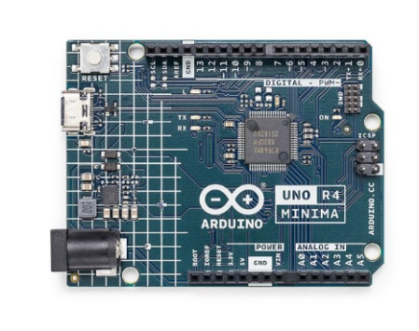
Figure 19 Arduino UNO R4 Minima (ABX00080)

At the heart of the UNO R4 Minima is a 48 MHz ARM Cortex-M4 processor, a substantial upgrade from the 16 MHz 8-bit AVR microcontroller in the UNO R3. This increased clock speed and architecture allow the board to process sensor inputs (such as those from the potentiometer and FSR sensor) and output PWM signals to the servo motor with minimal latency, which is essential for delivering responsive and stable haptic feedback. The M4 core also features a Floating-Point Unit (FPU), enabling more precise calculations for rendering virtual walls or damping forces in the Hapkit system.
The UNO R4 Minima also comes with 256 kB of flash memory and 32 kB of SRAM, providing ample space for storing complex control algorithms, libraries (such as PID, Servo, or custom haptic routines), and real-time variables. This memory headroom allows us to scale the complexity of our feedback loops or even implement frequency-domain system identification techniques if desired, as done in professional haptic research.
Another reason for selecting the UNO R4 Minima is its compatibility with existing Arduino shields and libraries, which accelerates development and integration. It supports 5V logic, making it directly compatible with traditional components like the FSR402 force sensor, REES52 MG945 servo motor, and analog potentiometers used in our Hapkit. Its multiple PWM and analog input pins allow us to precisely read user inputs and control motor response, creating a seamless and responsive haptic interaction.
Additionally, the Minima version, while lacking the on-board debugger and network features of the UNO R4 Wi-Fi, provides a cost-effective, compact, and minimalistic platform ideal for dedicated embedded haptic systems where Wi-Fi connectivity is not required. This ensures our system remains affordable and focused on real-time performance without unnecessary overhead.
In conclusion, the Arduino UNO R4 Minima is a robust and modern microcontroller platform that enhances our Hapkit by offering fast processing, low-latency control, and precise analog/digital interfacing. Its features align well with the goals of our project—low-cost, high-performance, and educationally accessible haptic feedback implementation—making it the ideal control unit for our open-source haptic device.

3D-printed parts

The Hapkit's 3D-printed structural components play a critical role in maintaining mechanical integrity, enabling precise alignment, and supporting the device's overall kinematic and electromechanical architecture. These parts include the sector pulley, base plate, height bar, and drive wheel, each meticulously designed to meet the system's spatial and functional requirements.
We employed Fused Deposition Modelling (FDM) to fabricate these components using the Flashforge Creator Pro 3D printer, known for its dual extrusion capabilities and high-resolution output, making it suitable for producing dimensionally accurate and mechanically reliable parts. The material selected for all printed components is polylactic acid (PLA) due to its high stiffness-to-weight ratio, minimal warping, environmental friendliness, and ease of use in desktop FDM applications.
The STL design files for these 3D components were sourced directly from Stanford University’s Hapkit open-source repository, ensuring compatibility with the original system specifications and preserving design integrity. These files provided a robust starting point for fabrication, with the flexibility to make minor modifications as needed for local integration.

Rotary encoder

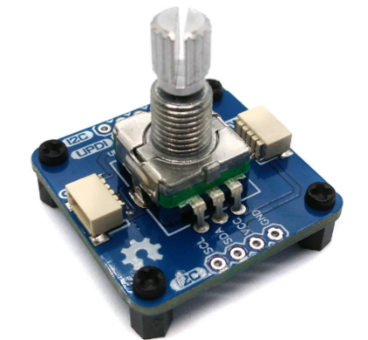
Figure 20 Rotary Encoder

A rotary encoder is an essential component in haptic devices like the Hapkit, as it enables precise measurement of angular position and motion, which is critical for implementing real-time feedback control. Unlike potentiometers, rotary encoders provide incremental or absolute digital signals that can be used to continuously monitor the rotation of a shaft with high resolution and accuracy. In our Hapkit project, the encoder works alongside the motor to form a closed-loop system, allowing the controller to adjust force outputs based on the user’s exact position. This capability is crucial for simulating virtual constraints such as walls, springs, or dynamic resistance fields. Rotary encoders are particularly well-suited for haptic applications because they do not suffer from wear and signal degradation over time, as potentiometers often do. While integrating an encoder requires careful wiring and signal interpretation—typically using interrupts or quadrature decoding with a microcontroller like Arduino—the result is a highly responsive and adaptable interface. For our prototype, the rotary encoder ensures that the system can detect subtle user motions and provide realistic feedback, making it a key element in delivering an immersive and interactive haptic experience.

Working of The Hapkit

Our Hapkit system has been developed with the goal of providing intuitive force feedback to users. The system is designed around an open-source haptic architecture inspired by Stanford University's Hapkit project, with custom modifications to integrate a DC brushed motor, a force-sensitive resistor (FSR402) embedded in the handle, a neoprene belt drive system, and 3D-printed structural components.
The central microcontroller used is the Arduino UNO R4 Minima, which runs the closed-loop control code for monitoring user interaction and generating feedback. The device operates as an impedance-type haptic system, which means it computes the output force based on the user’s position.
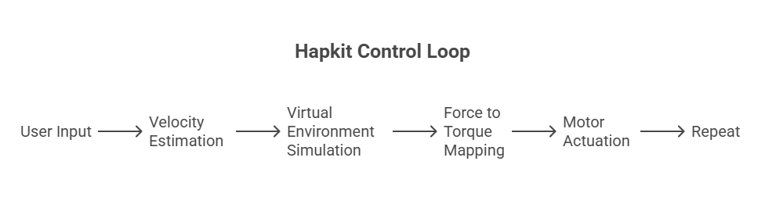
Figure 21 Impedance Control Loop of a Hapkit

This feedback system enables the simulation of virtual walls and the sensation of resistance when a user moves beyond defined spatial boundaries. The user manipulates a sector pulley, which is driven by the servo motor through a neoprene drive belt. This neoprene belt provides a reliable and backlash-minimized means of torque transmission.
The FSR402 sensor is embedded in the handle of the sector pulley, detecting grip force. This allows the system to optionally adjust resistance based on the pressure applied by the user, creating a more immersive and adaptable feedback experience. Meanwhile, the servo motor acts as the primary actuator, providing controlled rotational resistance or assistance depending on the user's position relative to a virtual wall.
The system continuously samples the angular position of the sector pulley via the servo motor’s internal feedback mechanism. Using these angle measurements, the Arduino computes the end-effector’s Cartesian coordinates via forward kinematics. The device then compares the current position to a predefined geometry. If the position lies within the defined boundary, no resistance is applied. If the user exceeds the boundary, the servo motor is commanded to resist motion or guide the user back into the path.

Code

The following Arduino code implements the described haptic feedback system. It continuously reads the potentiometer to determine the user's position, calculates the corresponding force using spring-damper dynamics and wall constraints, and actuates a servo motor to provide real-time force feedback. Additionally, it reads the force-sensing resistor (FSR) to monitor the user's applied pressure.
- Initialization

#include <Servo.h>
Servo motor;

const int motorPin = 9;
const int potPin = A0;
const int fsrPin = A1;

const double pi = 3.14159;
const double updatedPosMin = 0;
const double updatedPosMax = 1023;

const double rp = 0.006; // radius of pulley [m]
const double rs = 0.0125; // radius of servo shaft [m]
const double rh = 0.076; // radius of arc [m] (7.6 cm)

double updatedPos;
double xh, vh, ah; // position, velocity, acceleration
double force, Tp; // force and torque
unsigned long currentTime, prevTime;
double deltaTime = 0.0;
double xh_prev = 0.0;

This section initializes the necessary variables, constants, and pins. The Servo object is declared to control the motor. Pin numbers for the motor, potentiometer, and FSR sensor are defined. Constants like the radius of the pulley, servo shaft, and arc are provided for calculating the kinematics and dynamics of the system. Variables for position (xh), velocity (vh), acceleration (ah), and force (force) are declared and initialized.

- Setup

void setup() {
motor.attach(motorPin);
Serial.begin(9600);
prevTime = millis();
}

In the setup section, the servo motor is attached to the specified PWM pin. Serial communication is started for debugging and data logging. The prevTime variable is initialized to keep track of the time for velocity and acceleration computations.

- Main Loop

void loop() {
currentTime = millis();
deltaTime = (currentTime - prevTime) / 1000.0;

updatedPos = analogRead(potPin);
double ts = -0.0107 * updatedPos + 4.9513; // in degrees
double theta_rad = ts * pi / 180.0;
xh = rh * theta_rad;

vh = (xh - xh_prev) / deltaTime;
ah = (vh - (xh_prev - xh_prev) / deltaTime) / deltaTime;
xh_prev = xh;
prevTime = currentTime;
This segment reads the potentiometer value and maps it to an angular position using a linear relationship. The position (xh) is computed in meters based on the arc's radius. Using time differences, it calculates velocity (vh) and acceleration (ah) in real-time. These values are updated every loop iteration to simulate continuous motion tracking.

- Force Model
double k_spring = 500.0; // N/m
double b_damper = 0.25; // Ns/m
double x_wall = -0.02; // wall at -2 cm

double spring_force = -k_spring * xh;
double damping_force = -b_damper * vh;
double wall_force = 0.0;

if (xh < x_wall) {
wall_force = -600.0 * (xh - x_wall);
}

force = spring_force + damping_force + wall_force;
Tp = (rp / rs) * rh * force;
Here, a simple physical model is applied: a spring-damper system with a virtual wall. The force is calculated based on the user’s displacement (xh) and velocity (vh). If the user crosses a boundary at x_wall, a repelling force is added, simulating a physical wall. The total force is converted into torque Tp for motor control using geometric ratios.

- Motor Control
int PWM = map(Tp * 1000, -100, 100, 0, 180);
PWM = constrain(PWM, 0, 180);
motor.write(PWM);
The calculated torque is scaled and mapped to a PWM signal suitable for the servo motor. map() scales the torque range into servo-acceptable angles (0–180 degrees), and constrain() ensures the values don’t exceed safe limits. The motor is then commanded to exert the necessary force.

- FSR Sensor Read and Serial Output
int fsrValue = analogRead(fsrPin);
float fsrVoltage = fsrValue * (5.0 / 1023.0);
float fsrResistance = (fsrVoltage > 0) ? (10000.0 * (5.0 - fsrVoltage) / fsrVoltage) : 1000000.0;
float fsrForce = 0.0;

if (fsrResistance != 0) {
fsrForce = 1.0 / fsrResistance * 100000.0; // approx calibration
}

Serial.print("Pos: ");
Serial.print(xh, 4);
Serial.print(" m\tForce: ");
Serial.print(force, 2);
Serial.print(" N\tFSR: ");
Serial.println(fsrForce, 2);

delay(10);
}
The Force Sensitive Resistor (FSR402) is read to estimate the user-applied pressure. The analog reading is converted to voltage, then to resistance, and finally approximated as force. This reading is used for feedback or monitoring. All key variables—position, force, and FSR force—are output to the Serial Monitor for debugging and observation.

Mechanics of the Device

The Hapkit system is a 1-DOF haptic interface that operates on the principle of impedance control, where position input is used to modulate force feedback output. Mechanically, the system consists of a sector pulley coupled to a high-torque servo motor via a flexible neoprene belt drive. The angular motion of the handle, attached to the pulley, is thus directly influenced by the motor torque and resisted as needed to simulate virtual boundaries or walls.

Kinematic Configuration

The Hapkit system is designed with a single rotational degree of freedom (DOF), which corresponds to the angular displacement of the sector pulley about its fixed axis of rotation. This rotational motion is directly driven by the user through a handle mounted on the pulley, and it serves as the primary input for the haptic interface.
Kinematically, the system’s input can be described as a function of the arc length traversed by the user’s hand at the edge of the pulley. This relationship is mathematically modelled as
$$θ(t)=\frac{s(t)}{r}​$$
where:
- θ(t) is the angular displacement at time t,
- s(t) is the arc length traversed by the handle (in linear distance),
- r is the effective radius of the pulley (i.e., the distance from the axis of rotation to the point of user interaction).
This expression captures the proportional relationship between the linear motion of the handle and the corresponding angular displacement, assuming no slippage in the transmission (i.e., ideal belt drive conditions).
The angular resolution—or the precision with which θ(t) can be measured—is governed by the sensing mechanism integrated into the system. Typically, this is achieved using an external rotary encoder if higher resolution and absolute positioning are required.
The selection of the sensor affects both the spatial resolution and the response time of the feedback loop, which are critical for accurate haptic rendering. Additionally, the fixed rotational axis ensures planar motion, allowing simplified control and analysis of the system's dynamic behavior.
This kinematic model lays the foundation for implementing impedance-based control, where θ(t) serves as the primary feedback variable for determining the corresponding torque output from the actuator.

Force Transmission

In the Hapkit system, torque generation and delivery to the user’s hand is a central component of haptic feedback. The actuator—a high-torque servo motor—produces a torque​, which is transmitted to the sector pulley via a neoprene timing belt. This compliant belt drive plays a dual role: it effectively transfers mechanical power while also acting as a low-pass filter, attenuating high-frequency oscillations and reducing backlash typically observed in rigid coupling systems.
The torque experienced by the user at the handle, denoted by, is a function of the motor torque and the mechanical transmission efficiency $η$of the belt system:
$$τ_{handle}= η⋅τ​_{m}$$
Here, η typically ranges from 0.85 to 0.95 under low-load and low-speed conditions, depending on factors such as belt tension, pulley alignment, and friction losses.
The haptic feedback perceived by the user is simulated by dynamically modulating the motor torque based on a virtual environment model programmed in software. The system continuously reads the angular position θ(t) from the sensor and applies a computed motor torque to replicate physical phenomena. For example, to simulate a virtual wall located at an angular position, a restoring torque is applied when the user attempts to move the handle beyond the wall boundary. This torque can be modeled using a simple spring-like impedance equation:
$$τ_{feedback}=-k\left(θ-θ_{wall }​\right) for θ>θ_{wall}​$$
where:
- k is a virtual stiffness constant representing the "hardness" of the wall.
- θ is the current angular position of the handle.
- is the counteracting torque applied by the motor.
This mechanism allows the user to feel a resistive force as they encounter the virtual constraint, effectively rendering a tactile illusion of a solid barrier. By adjusting k, the wall can be made "softer" or "harder," depending on the desired interaction profile. Such software-defined torque rendering opens a wide range of haptic interactions—from elastic springs and dampers to rigid constraints—using just a single DOF mechanical system with cost-effective components.

Structural Mechanics
All structural components—including the motor mount, sector pulley, and baseplate—are fabricated using PLA filament on a FlashForge Creator Pro 3D printer. PLA was chosen due to its adequate rigidity, dimensional accuracy, and thermal stability under the relatively low mechanical loads encountered in typical haptic interactions. These components are assembled with high precision to ensure proper alignment between the motor shaft, rotational axis, and belt tensioner. Such alignment is critical for minimizing mechanical play and ensuring reliable performance during dynamic actuation. A key mechanical feature of the design is the bearing-mounted pulley, which is suspended above the baseplate. This configuration allows the pulley to rotate smoothly over the motor shaft, significantly reducing friction. The use of a low-friction bearing interface ensures consistent and low-resistance motion, which is essential for delivering accurate and high-fidelity haptic feedback to the user.

Sensor Integration and Mechanical Interface

An FSR402 force-sensitive resistor is integrated at the handle-grip interface to measure the grip force applied by the user $F_{user}$ . This sensor provides real-time feedback on the user's physical interaction with the device, enabling dynamic modulation of the haptic response.
Mechanically, the measured grip force is used to adapt the stiffness of virtual environments in real time. For instance, a higher grip force can be interpreted as the user's readiness for stronger resistance, and the system correspondingly increases the virtual wall stiffness. This adaptive behavior is modeled as:
$${τ​}_{adaptive}=f(F_{user}​)⋅(θ-θ_{max}​)$$
where:
- ​${τ​}_{adaptive}$ is the torque output based on grip force,
- $\left(F_{user}​\right)$is a gain function that increases with grip force,
- Θ is the current angular position.
- $θ_{max}$ is the boundary of the virtual wall.
This force-dependent control strategy enhances the interactivity and realism of haptic feedback and is particularly valuable in motor skill training applications, such as handwriting assistance and rehabilitation therapy, where responsiveness to user intent is critical.
System Constraints and Physical Limits
The system’s angular range of motion is mechanically limited by the geometry of the sector pulley, typically constrained to ±90°, yielding a total range of approximately 180°. To prevent over-rotation and potential mechanical damage, physical hard stops are integrated into the design. These hard stops act as a safety feature, protecting both the motor and the 3D-printed structural components from excessive stress.
Additionally, the compliance of the neoprene belt provides a passive damping effect, absorbing sudden torque spikes that may occur during aggressive user interactions. This not only improves the mechanical robustness of the device but also enhances the perceived smoothness of haptic feedback, contributing to a more stable and resilient user experience during prolonged use.

Conclusion
In conclusion, The Hapkit stands as a versatile and accessible platform for investigating and experiencing haptic feedback technology. It bridges the gap between expensive, specialized commercial systems and simple educational tools, offering a modular, cost-effective solution suitable for both academic research and hands-on learning. The device successfully demonstrates the core principles of haptic interaction by providing intuitive force feedback through a well-engineered mechanical design and effective control strategies. While the current implementation achieves its primary goals, there are opportunities to improve accuracy, responsiveness, and user comfort, which would broaden its applicability in areas such as virtual reality simulations, teleoperation, and rehabilitation. By maintaining a focus on simplicity and essential features, the Hapkit ensures ease of use and replicability, enabling students, educators, and researchers to engage deeply with haptic concepts without the barrier of complex hardware or software. This accessibility aligns with the growing importance of haptics in emerging technologies and their potential to enhance human-computer interaction.
Looking ahead, integrating advanced control algorithms, expanding device functionality, and developing customizable interfaces can elevate the Hapkit’s impact. Its adaptability positions it as a valuable tool for innovation, education, and practical application in the expanding field of haptic technology. Ultimately, Hapkit embodies a step forward in making sophisticated tactile feedback systems approachable and practical, fostering a deeper understanding and wider adoption of haptic interfaces in diverse domains.

Future Works

While the current version of the Hapkit effectively demonstrates fundamental haptic feedback and interaction, there is considerable room for enhancement. Future iterations could implement advanced control algorithms such as PID tuning, adaptive feedback systems, or even machine learning-based models to better simulate realistic user responses and improve precision.
On the hardware side, using higher-resolution sensors, compact actuators, and modular components would expand the device’s versatility, enabling configurations suited for a range of applications—from virtual skill training to teleoperation and surgical simulation. A dedicated graphical user interface (GUI) could further improve usability, allowing real-time tuning of parameters like stiffness, damping, and force intensity. Additional upgrades might include wireless connectivity and battery-powered operation, making the system more portable and accessible. In education, the platform can evolve to support interactive learning modules across diverse disciplines such as biomechanics, rehabilitation, and STEM education.
In summary, with targeted improvements in both hardware and software, the Hapkit has the potential to transition from an educational tool to a robust haptic development platform, driving innovation in both academic and applied settings.

7. References

- Alexandra Miller Naveed D. Riaziat and Jeremy D. Brown An Open-Source Ungrounded Hap kit for Educational Applications [Journal].
- Christopher Richard Allison M. Okamura and Mark R. Cutkosky Getting a Feel For Dynamics: Using Haptic Interface Kits for Teaching Dynamics and Controls [Journal].
- Das Hailu Gebretsadik Teklemariam & A. K. A case study of phantom omni force feedback device for virtual product design [Book].
- Eloy Irigoyen Mikel Larrea, Manuel Graña A Narrative Review of Haptic Technologies and Their Value for Training, Rehabilitation, and the Education of Persons with Special Needs. [Journal].
- M. Sreelakshmi T.D. Subhash RETRACTED: Haptic Technology: A comprehensive review on its applications and future prospects [Book]. - 2017.
- Martinez Melisa Orta Design and analysis of open-source educational haptic devices [Journal].
- Melisa Orta Martinez Cara M. Nunez, Ting Liao, Tania k. Morimoto Evolution an Analysis of Hap kit [Journal].
- Muhammad Fouad Tamer Mansour , Tamer Nabil Use of haptic devices in education: A review [Journal].
- Seeed Stanford University x Open-Source Haptic Device for Affordable Haptics Education for All: [Journal].
- Zhenxing Li Mila BujićOğuz ‘Oz’ , BurukElpida BampouniSimo, JärveläJuho Hamari :Haptics-mediated virtual embodiment: Impact of a wearable avatar-controlling system with kinesthetic gloves on embodiment in VR [Book].

